**OS and Programming platforms**

**Feba Elizabath Sabu**

**AM.BT.P2BIF20015**

Installed LINUX MINT and UBUNTU in Virtual box

**Virtual box**

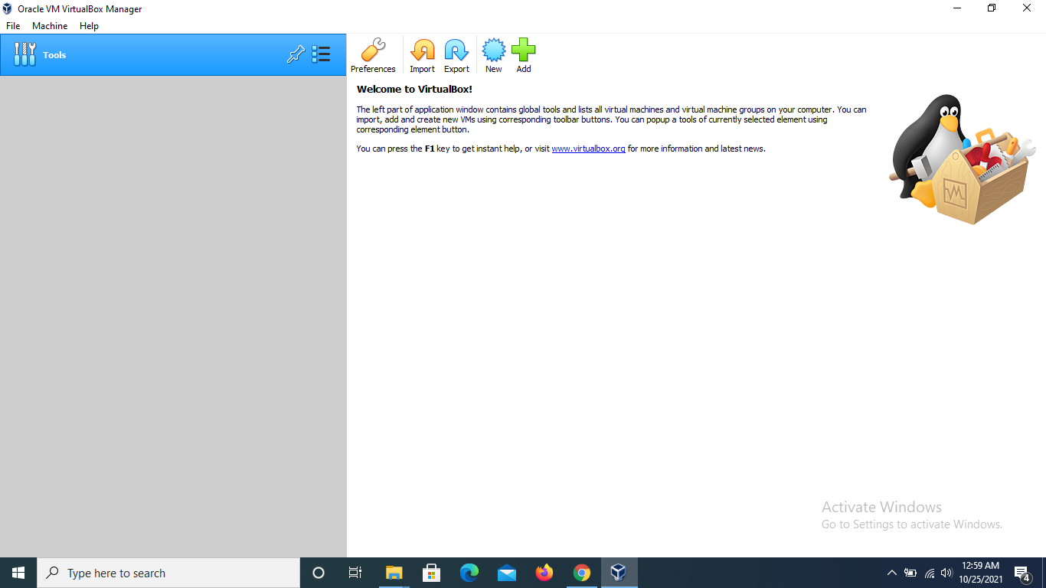

Installed Oracle VM virtual box.

Allows users to extend their existing computer to run multiple operating systems including Linux,Oracle solaris ,at the same time.

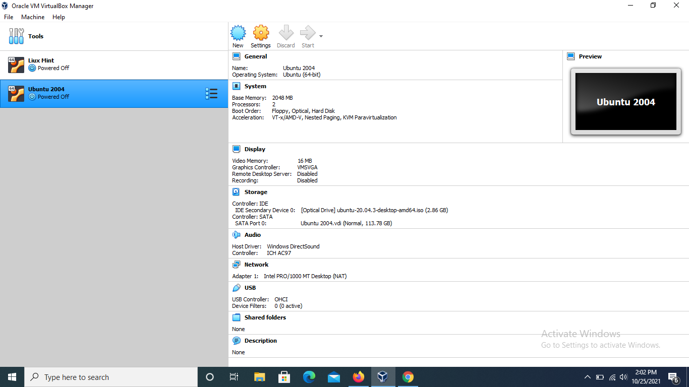

**Linux Mint 20.2**

Linux mint is an operating system,completely free of charge,fully equipped with the apps most people need.

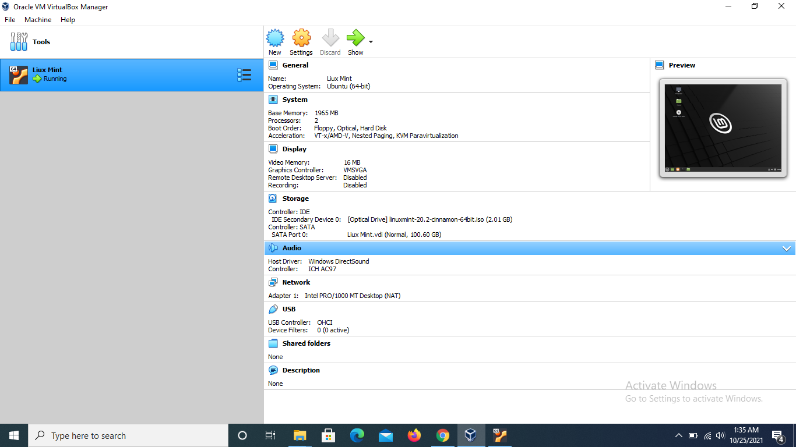

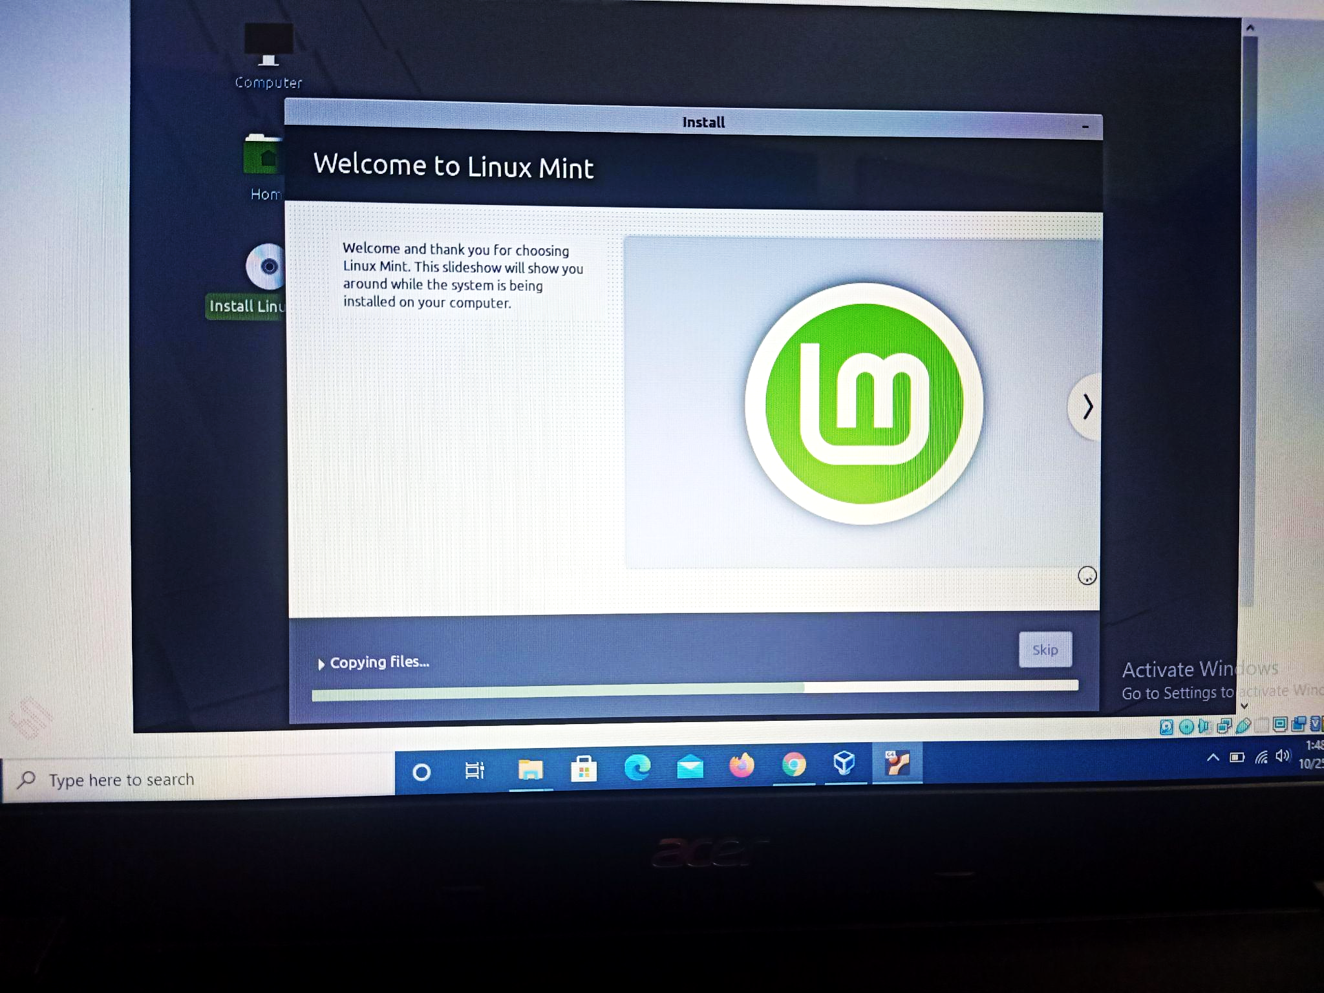

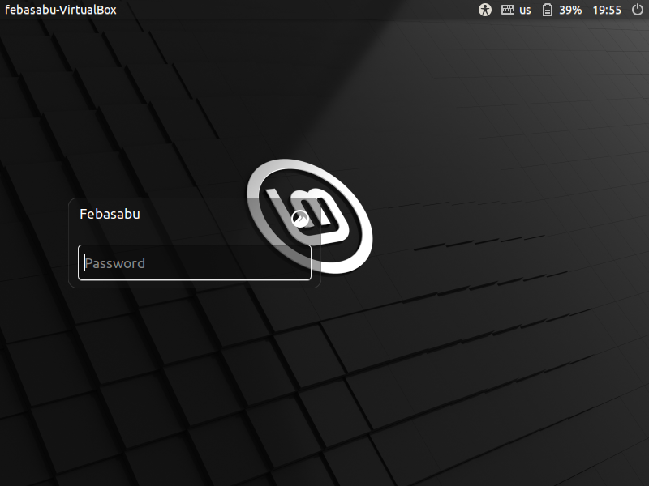

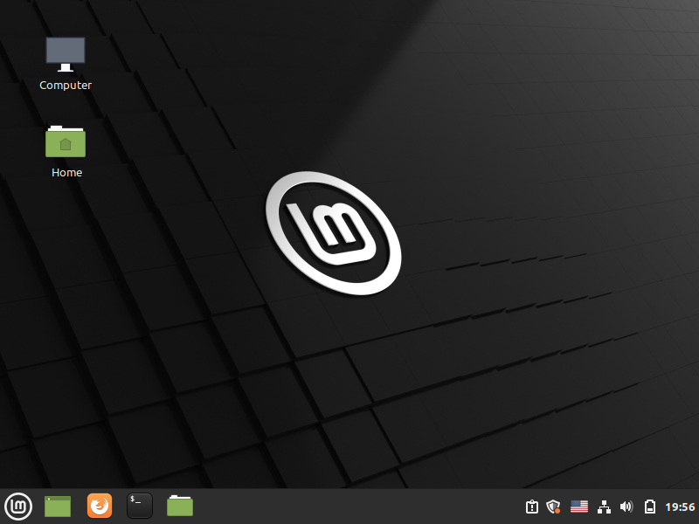

**Ubuntu 20.04**



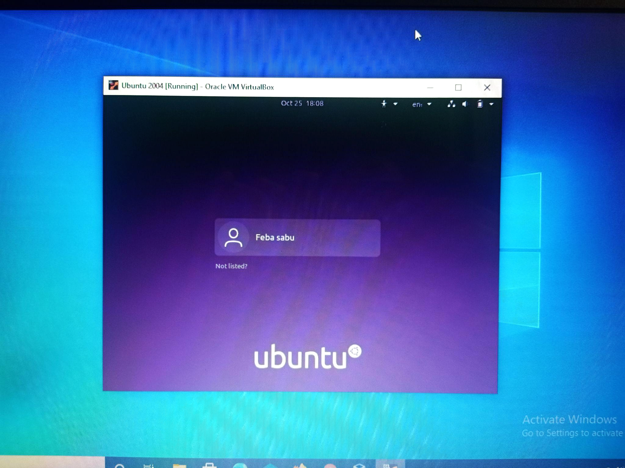

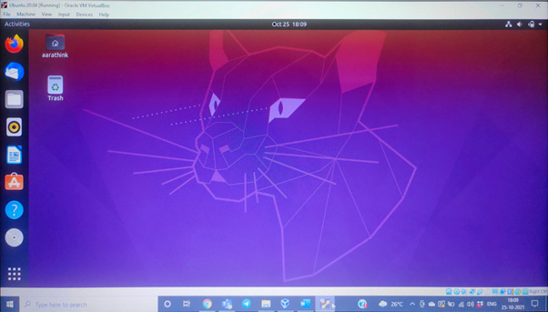

Q) What is shell and kernel?

Shell and the kernel are parts of this operating system.These Both Parts are used for performing any Operation on the System. When a user gives his Command for Performing Any Operation, then the Request Will goes to the Shell Parts, The Shell Parts is also called as the Interpreter which translates the Human Program into the Machine Language and then the Request will be transferred to the Kernel. So that Shell is just called as the interpreter of the Commands which converts the Request of the User into the Machine Language.Kernel is also called as the heart of the Operating System and the every Operation is performed by using the Kernel, When the Kernel Receives the Request from the Shell then this will Process the Request and Display the Results on the Screen.

Linux Mint 20 features Cinnamon 4.6, **a Linux kernel 5.4**

Shell: **Bash**

Ubuntu 20.04 ,**a linux kernel 5.4**

Shell:  **GNU Bash**

**Q) What does OS mean?**

An operating system is the most important software that runs on a computer. It manages the computer's memory and processes, as well as all of its software and hardware. It also allows you to communicate with the computer without knowing how to speak the computer's language.

Most of the time, there are several different computer programs running at the same time, and they all need to access your computer's central processing unit (CPU), memory, and storage. The operating system coordinates all of this to make sure each program gets what it needs.

Three most common operating systems for personal computers are Microsoft Windows, macOS, and Linux.